**USA HOUSING PRICE PREDICTION**

***1)*** import pandas as pd

***2)*** # Load the dataset

file_path = "/content/USA_Housing (1).csv"

df = pd.read_csv(file_path)

# Display basic information about the dataset

df.info(), df.head()

***OUTPUT***

<class 'pandas.core.frame.DataFrame'>

RangeIndex: 5000 entries, 0 to 4999

Data columns (total 7 columns):

# Column Non-Null Count Dtype

--- ------ -------------- -----

0 Avg. Area Income 5000 non-null float64

1 Avg. Area House Age 5000 non-null float64

2 Avg. Area Number of Rooms 5000 non-null float64

3 Avg. Area Number of Bedrooms 5000 non-null float64

4 Area Population 5000 non-null float64

5 Price 5000 non-null float64

6 Address 5000 non-null object

dtypes: float64(6), object(1)

memory usage: 273.6+ KB

(None,

Avg. Area Income Avg. Area House Age Avg. Area Number of Rooms \

0 79545.458574 5.682861 7.009188

1 79248.642455 6.002900 6.730821

2 61287.067179 5.865890 8.512727

3 63345.240046 7.188236 5.586729

4 59982.197226 5.040555 7.839388

Avg. Area Number of Bedrooms Area Population Price \

0 4.09 23086.800503 1.059034e+06

1 3.09 40173.072174 1.505891e+06

2 5.13 36882.159400 1.058988e+06

3 3.26 34310.242831 1.260617e+06

4 4.23 26354.109472 6.309435e+05

Address

0 208 Michael Ferry Apt. 674\nLaurabury, NE 3701...

1 188 Johnson Views Suite 079\nLake Kathleen, CA...

2 9127 Elizabeth Stravenue\nDanieltown, WI 06482...

3 USS Barnett\nFPO AP 44820

4 USNS Raymond\nFPO AE 09386 )

*3)* # Check for duplicate rows

duplicate_rows = df.duplicated().sum()

*4)* # Check for outliers using summary statistics

summary_stats = df.describe()

duplicate_rows, summary_stats

***OUTPUT***

(0,

Avg. Area Income Avg. Area House Age Avg. Area Number of Rooms \

count 5000.000000 5000.000000 5000.000000

mean 68583.108984 5.977222 6.987792

std 10657.991214 0.991456 1.005833

min 17796.631190 2.644304 3.236194

25% 61480.562388 5.322283 6.299250

50% 68804.286404 5.970429 7.002902

75% 75783.338666 6.650808 7.665871

max 107701.748378 9.519088 10.759588

Avg. Area Number of Bedrooms Area Population Price

count 5000.000000 5000.000000 5.000000e+03

mean 3.981330 36163.516039 1.232073e+06

std 1.234137 9925.650114 3.531176e+05

min 2.000000 172.610686 1.593866e+04

25% 3.140000 29403.928702 9.975771e+05

50% 4.050000 36199.406689 1.232669e+06

75% 4.490000 42861.290769 1.471210e+06

max 6.500000 69621.713378 2.469066e+06 )

***5)*** # Display basic info and first few rows

df.info(), df.head()

***OUTPUT***

<class 'pandas.core.frame.DataFrame'>

RangeIndex: 5000 entries, 0 to 4999

Data columns (total 7 columns):

# Column Non-Null Count Dtype

--- ------ -------------- -----

0 Avg. Area Income 5000 non-null float64

1 Avg. Area House Age 5000 non-null float64

2 Avg. Area Number of Rooms 5000 non-null float64

3 Avg. Area Number of Bedrooms 5000 non-null float64

4 Area Population 5000 non-null float64

5 Price 5000 non-null float64

6 Address 5000 non-null object

dtypes: float64(6), object(1)

memory usage: 273.6+ KB

(None,

Avg. Area Income Avg. Area House Age Avg. Area Number of Rooms \

0 79545.458574 5.682861 7.009188

1 79248.642455 6.002900 6.730821

2 61287.067179 5.865890 8.512727

3 63345.240046 7.188236 5.586729

4 59982.197226 5.040555 7.839388

Avg. Area Number of Bedrooms Area Population Price \

0 4.09 23086.800503 1.059034e+06

1 3.09 40173.072174 1.505891e+06

2 5.13 36882.159400 1.058988e+06

3 3.26 34310.242831 1.260617e+06

4 4.23 26354.109472 6.309435e+05

Address

0 208 Michael Ferry Apt. 674\nLaurabury, NE 3701...

1 188 Johnson Views Suite 079\nLake Kathleen, CA...

2 9127 Elizabeth Stravenue\nDanieltown, WI 06482...

3 USS Barnett\nFPO AP 44820

4 USNS Raymond\nFPO AE 09386 )

***6)*** import seaborn as sns

import matplotlib.pyplot as plt

***7)*** # Drop Address column as it's not useful for analysis

df_cleaned = df.drop(columns=['Address'])

***8)*** # Summary statistics

summary_stats = df_cleaned.describe()

***9)*** # Correlation matrix

correlation_matrix = df_cleaned.corr()

***10)*** # Visualization - Correlation Heatmap

plt.figure(figsize=(10, 6))

sns.heatmap(correlation_matrix, annot=True, cmap="coolwarm", fmt=".2f")

plt.title("Correlation Heatmap")

plt.show()

summary_stats

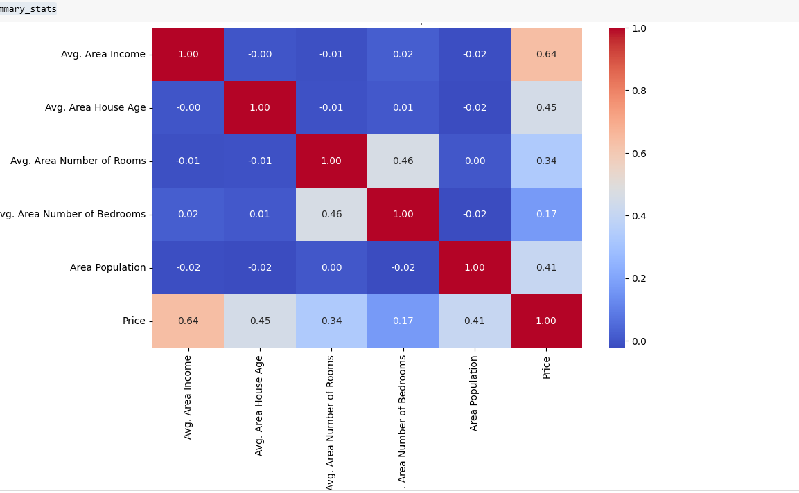

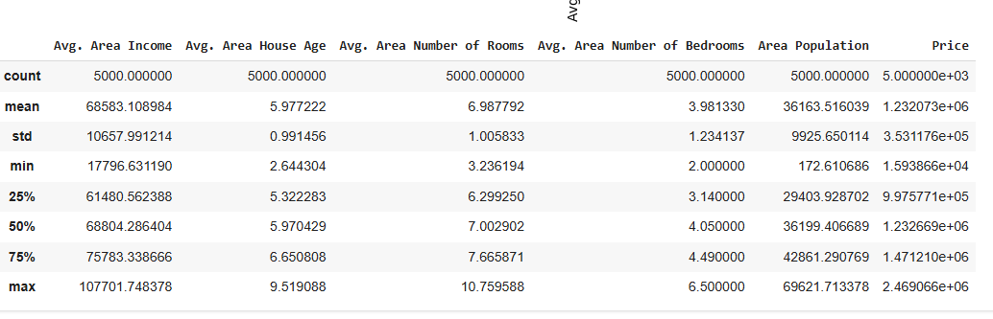

***11)*** # Display basic information and first few rows

df.info(), df.head()

<class 'pandas.core.frame.DataFrame'>

RangeIndex: 5000 entries, 0 to 4999

Data columns (total 7 columns):

# Column Non-Null Count Dtype

--- ------ -------------- -----

0 Avg. Area Income 5000 non-null float64

1 Avg. Area House Age 5000 non-null float64

2 Avg. Area Number of Rooms 5000 non-null float64

3 Avg. Area Number of Bedrooms 5000 non-null float64

4 Area Population 5000 non-null float64

5 Price 5000 non-null float64

6 Address 5000 non-null object

dtypes: float64(6), object(1)

memory usage: 273.6+ KB

(None,

Avg. Area Income Avg. Area House Age Avg. Area Number of Rooms \

0 79545.458574 5.682861 7.009188

1 79248.642455 6.002900 6.730821

2 61287.067179 5.865890 8.512727

3 63345.240046 7.188236 5.586729

4 59982.197226 5.040555 7.839388

Avg. Area Number of Bedrooms Area Population Price \

0 4.09 23086.800503 1.059034e+06

1 3.09 40173.072174 1.505891e+06

2 5.13 36882.159400 1.058988e+06

3 3.26 34310.242831 1.260617e+06

4 4.23 26354.109472 6.309435e+05

Address

0 208 Michael Ferry Apt. 674\nLaurabury, NE 3701...

1 188 Johnson Views Suite 079\nLake Kathleen, CA...

2 9127 Elizabeth Stravenue\nDanieltown, WI 06482...

3 USS Barnett\nFPO AP 44820

4 USNS Raymond\nFPO AE 09386 )

***12)*** #Plot histograms for feature distributions

df.hist(figsize=(12, 8), bins=30, edgecolor='yellow')

plt.suptitle("Feature Distributions", fontsize=16)

plt.show()

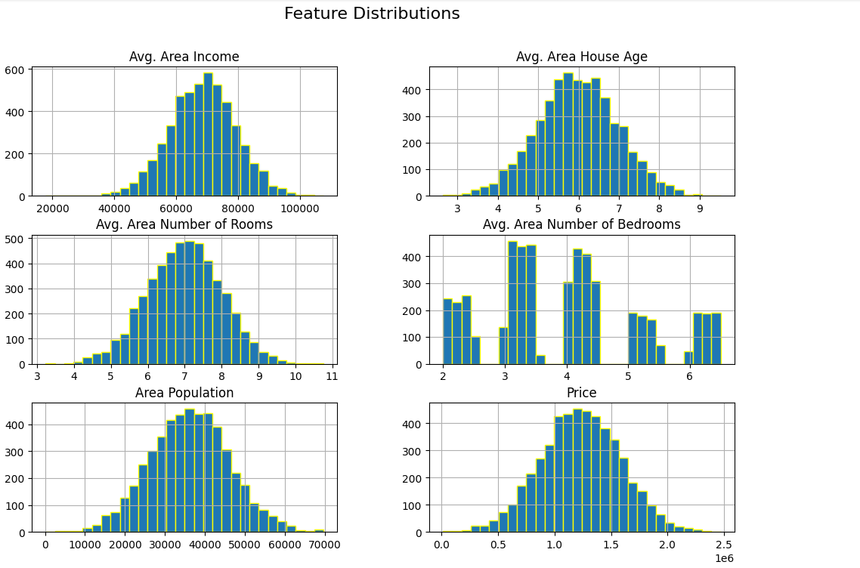

**13)** # Scatter plots to check relationships with house prices

fig, axes = plt.subplots(2, 3, figsize=(18, 12))

features = ["Avg. Area Income", "Avg. Area House Age", "Avg. Area Number of Rooms",

            "Avg. Area Number of Bedrooms", "Area Population"]

for ax, feature in zip(axes.flat, features):

    sns.scatterplot(x=df[feature], y=df["Price"], ax=ax, alpha=0.5)

    ax.set_title(f"{feature} vs Price")

plt.tight_layout()

plt.show()

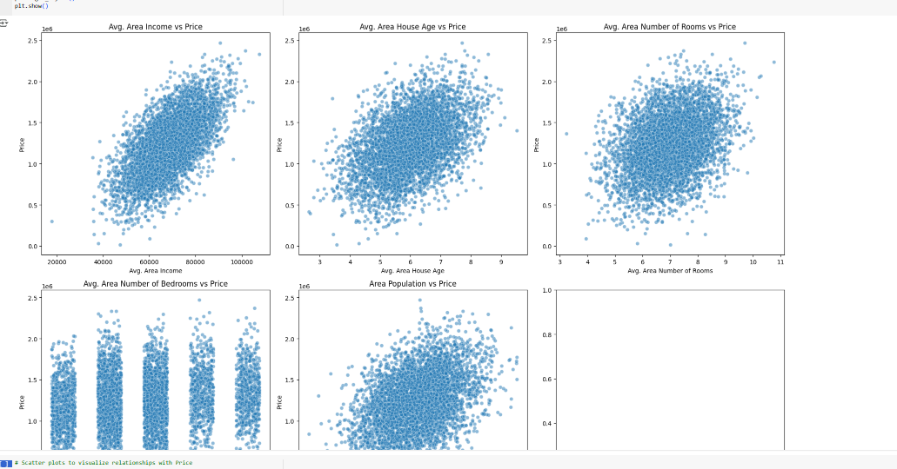

***14)*** # Scatter plots to visualize relationships with Price

fig, axes = plt.subplots(2, 2, figsize=(12, 10))

sns.scatterplot(x=df["Avg. Area Income"], y=df["Price"], ax=axes[0, 0], alpha=0.5)

axes[0, 0].set_title("Price vs. Avg. Area Income")

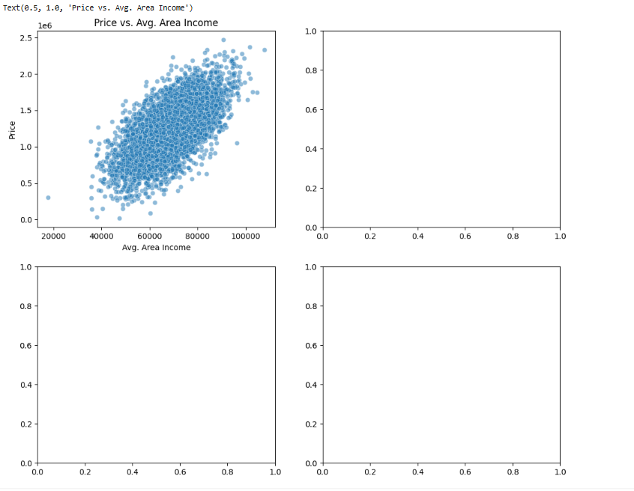

***15)*** df.head(5)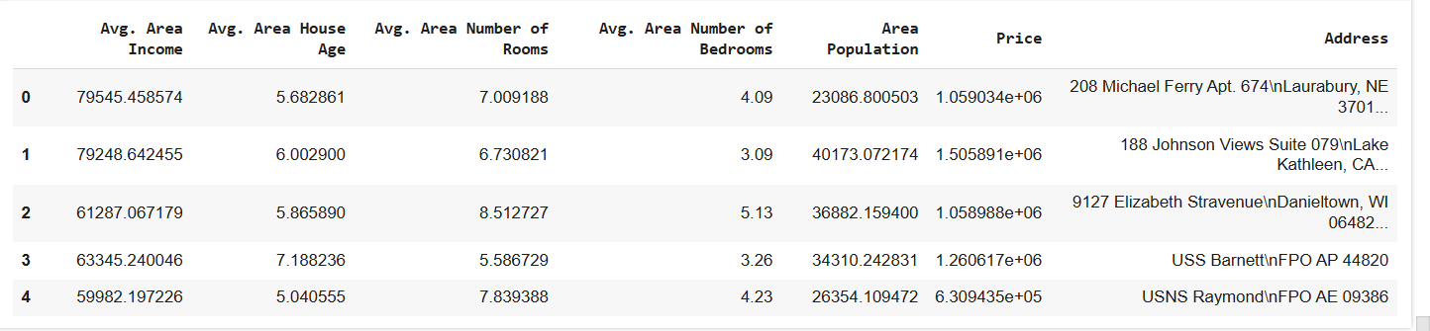

**16)** df.info()

<class 'pandas.core.frame.DataFrame'>

RangeIndex: 5000 entries, 0 to 4999

Data columns (total 7 columns):

# Column Non-Null Count Dtype

--- ------ -------------- -----

0 Avg. Area Income 5000 non-null float64

1 Avg. Area House Age 5000 non-null float64

2 Avg. Area Number of Rooms 5000 non-null float64

3 Avg. Area Number of Bedrooms 5000 non-null float64

4 Area Population 5000 non-null float64

5 Price 5000 non-null float64

6 Address 5000 non-null object

dtypes: float64(6), object(1)

memory usage: 273.6+ KB

**17)** df.isna().sum()

| **0** |
| --- |
| **Avg. Area Income** | 0 |
| **Avg. Area House Age** | 0 |
| **Avg. Area Number of Rooms** | 0 |
| **Avg. Area Number of Bedrooms** | 0 |
| **Area Population** | 0 |
| **Price** | 0 |
| **Address** | 0 |

**dtype:** int64

**18)** #checking column names

df.columns

Index(['Avg. Area Income', 'Avg. Area House Age', 'Avg. Area Number of Rooms',

'Avg. Area Number of Bedrooms', 'Area Population', 'Price', 'Address'],

dtype='object')

**19)** df['Avg. Area Number of Bedrooms'].nunique()

255

**20)** df['Avg. Area Number of Rooms'].nunique()

5000

**21)** df['Avg. Area House Age'].nunique()

5000

**22)** df['Avg. Area Income'].nunique()

5000

**23)** df["Area Population"].nunique()

5000